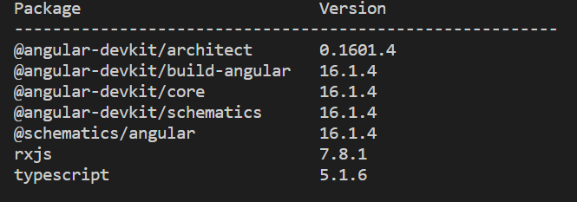

Note: Npm Packages required to test OCAP locally

If any of the package is missing, you can download these packages individually.

Ex. **npm install @angular-devkit/build-angular (or)**

**npm install @angular-devkit/build-angular –force**

To Update:

**ng update @ angular-devkit/build-angular**

**ng update @ angular-devkit/build-angular –force**

To check the version: **ng version**

To install the particular version**: nvm install 18.17.0**

1)To resolve the .lib/stringify error

Try uninstalling the package and re-install using the following commands

**a)npm uninstall stringify**

**b) npm i stringify -g**

**2)**To Fix the Sha Error/ Eintergrity : for any version of semver

**https://repo1.uhc.com:443/artifactory/api/npm/npm-virtual/semver/-/semver-6.3.1.tgz**

Copy the URL of that particular version of in browser - search of integrity value -replace this value in package.lock.json file

integrity" : "sha512-BR7VvDCVHO+q2xBEWskxS6DJE1qRnb7DxzUrogb71CWoSficBxYsiAGd+Kl0mmq/MprG9yArRkyrQxTO6XjMzA=="

**or**

Replace the value it is looking for in the Terminal error message.